**CHAPTER ONE**

**INTRODUCTION**

**1.1 BACKGROUND OF THE STUDY**

Facial recognition involves verifying or identifying a person based on their facial characteristics. The system analyzes facial features and compares patterns to establish identity and verify accuracy. Designing an invariant face recognition system presents challenges due to fluctuations in illumination, position, and age. (Hassan et al.,(2022)

For many years, face recognition has been a popular area of study in computer vision. Deep neural networks have enabled facial recognition models in deep learning-based techniques, enabling them to perform exceptionally well recently, beating humans in multiple circumstances. The conventional knowledge states that for better recognition performance, train face recognition models with vast amounts of data and margin-based measures to boost intra-class compactness.

( Conway et al.,2021)

Unlike other differences that are manageable throughout the picture capture period, facial ageing is an uncontrollable phenomenon that occurs throughout human life. Finding a suitable technique for age-invariant facial identification is made more difficult by the fact that facial ageing photographs contain extrinsic alterations related to illumination, position, and expression.

( Hassan A. et al., 2024)

Though generic face recognition (GFR) has been remarkably successful, minimizing the effect of age variation remains a persistent difficulty for existing face recognition algorithms in accurately identifying faces in many real-world applications, such tracking down long-missing children. Consequently, age-invariant face recognition, or AIFR, or face recognition without age change, is extremely important. But in the following three areas, AIFR is still quite difficult. Initially, age variation might take center stage in facial appearance when the age gap widens in cross-age face identification, severely impairing face recognition performance. Second, as facial appearance varies from person to person and changes dramatically over time, face age synthesis (FAS) is a complex process including face aging/rejuvenation (also known as age progression/regression).

The method and approach for age-invariant face recognition shown in this study uses deeply learnt features extracted from separated components (the eyes, nose, mouth, forehead, and cheeks). Matching score level fusion is then carried out, and cosine similarity is employed for classification.

**1.2 AIM AND OBJECTIVES**

**1.2.1 AIM**

The Aim of this project is to Design an AI application for age and facial detection.

**1.2.2 OBJECTIVES**

1. To develop a local dataset of 1000 images
2. To design an AI application using
3. To Evaluate the model

**1.3 PROBLEM STATEMENT**

Recent research underscores the persistent challenges faced by facial recognition systems due to the effects of aging on facial features. These studies highlights that facial recognition accuracy significantly deteriorates with age-related changes in facial characteristics, which are influenced by factors such as genetics, lifestyle, and environmental conditions (Ben Fredj et al., 2021). Other research focuses on age-invariant face recognition techniques that aim to mitigate these challenges by employing advanced algorithms designed to extract identity features that remain stable over time, thus minimizing the impact of aging (Xie, Pun, & Lam, 2022).

Specifically, researchers have been leveraging Convolutional Neural Networks (CNNs) and Vision Transformers (ViTs) to enhance the resilience of face recognition systems against the effects of aging. These models improve recognition accuracy by emphasizing features that do not change significantly with age, rather than those that are prone to age-related alterations (Huang et al., 2022).

These studies indicate ongoing efforts to address the degradation in performance of facial recognition systems due to aging, highlighting the importance of developing robust age-invariant recognition systems that can reliably match faces over extended periods (Ben Fredj et al., 2021; Xie, Pun, & Lam, 2022). This body of research contributes to the broader objective of enhancing the reliability and accuracy of biometric identification technologies in real-world applications.

Age invariance is a challenge for current face recognition algorithms, particularly when handling wide age differences. The majority of techniques either depend on computationally costly 3D face modeling or demand enormous training datasets spanning several decades. There is no full solution for reliable age-invariant face recognition.

The goal of this project is to provide a component-based approach that is efficient for age-invariant face identification. The main concept is to treat distinct parts of the face, such as the lips, nose, and eyes, differently as they age. To attain excellent accuracy across age groups, we shall employ support vector machines and discriminant correlation analysis.

The popular FG-NET face aging database will be utilized to assess the suggested solution. We expect it to beat current methods in terms of mean recognition accuracy, particularly for significant age disparities. By considering facial components separately, the method should be more resistant to facial aging than comprehensive techniques.

Face recognition will be able to be employed with reliability in a greater variety of real-world applications, such as biometrics, human-computer interaction, and surveillance, once the age-invariance problem is solved. The component-based method might potentially be used to other aging-related facial analysis tasks, like gender prediction and age estimation.

In summary, this project will create a unique component-based algorithm for age-invariant face recognition that outperforms the current state-of-the-art. The resulting technology will help to improve the robustness, reliability, and applicability of facial recognition.

**1.4 SCOPE OF STUDY:**

The major goal of this project is to develop a reliable system for real-time age and gender detection using pre-trained deep learning models. The project will leverage OpenCV to detect faces in images or video streams and accurately predict age and gender, providing an efficient and practical solution for various applications.

**Boundaries of the Project**:

**Methodology**

The project will use a deep learning-based approach to detect faces and predict age and gender in real-time. It involves loading pre-trained models with OpenCV, processing video frames or images to detect faces, and predicting age and gender for each face. The results are displayed in real-time, ensuring efficient and practical application.

**Data Sources**

The primary data source for this research will be the FG-NET face aging database, which offers a comprehensive collection of images depicting individuals at various ages. This dataset is particularly suitable for evaluating the effectiveness of the proposed method in handling age-related variations in facial features. While the FG-NET database will be the main focus, other datasets may be referenced for comparative analysis to validate the robustness and generalizability of the findings.

**Technological Constraints**

The project is constrained to utilizing conventional machine learning techniques, deliberately excluding advanced deep learning methods and 3D modeling approaches. This limitation is due to the extensive computational resources required for deep learning and 3D modeling, which are beyond the scope of the current research. Consequently, the project will focus on more traditional machine learning algorithms that are computationally efficient and accessible.

**Application Scope**

The outcomes of this research will be particularly relevant to fields such as security, surveillance, and biometric identification, where the ability to recognize individuals across different ages is crucial. The findings are expected to contribute to the development of more robust face recognition systems that can maintain high accuracy despite the natural aging process.

**Age Range**

The project will concentrate on a defined age range, encompassing different life stages from childhood to older adulthood. The proposed age categories for analysis are:

Childhood: 0-12 years

Adolescence: 13-19 years

Young Adults: 20-35 years

Middle Age: 36-55 years

Senior Adults: 56 years and above

**1.5 MOTIVATION OF STUDY**

Age detection procedures need to be accurate and dependable because more and more domains, including online services, security, and access control, are relying on digital platforms and automated systems for age verification. In addition to being laborious and prone to fraud and error, traditional methods of age verification sometimes entail manual inspections or document verification. An effective and smooth way to verify someone's age is using facial recognition technology, which presents a promising substitute.

However, age invariance is a major problem for facial recognition-based age verification, though. As people age, their faces alter, which can cause errors in age estimation algorithms. This is especially difficult for very precise systems, such age-restricted internet services, healthcare systems, and legal contexts. Erroneous age verification may result in misuse of services, illegal activity, and access being denied.

Improving age verification systems' accuracy and dependability requires addressing the age invariance issue. And through the creation of a strong model that can retain high accuracy in a range of age groups. This study seeks to address a key shortcoming of existing facial recognition technology. This would guarantee impartial and equitable results for all demographic groups in addition to enhancing the efficacy of age verification methods.

Moreover, the research motivation encompasses wider societal consequences. Ensuring precise age verification can aid in preventing children and other vulnerable groups from accessing unsuitable content or services. It can also improve user experience and operational efficiency by streamlining procedures across a range of industries.

**1.6 ORGANIZATION OF STUDY**

1.1 Background of the study

1.2 Aim and Objectives

1.2.1 Aim

1.2.2 Objectives

1.3 Problem Statement

1.4 Scope of the study

1.5 Motivation of the study

1.6 Organization of the study

**CHAPTER TWO**

**LITERATURE REVIEW**

**2.1 INTRODUCTION**

The objective of this literature review is to critically evaluate present research and approaches in age identification and verification for AI applications. This review will examine existing research to identify effective tactics, problems, and breakthroughs related to tackling age invariance in AI systems. Finally, this literature review will inform the building of a strong foundation for designing an AI application dedicated to accurate age identification and verification.

Facial recognition basically is the activity of verifying or identifying a person's identity through facial characteristics. It captures facial features, analyses, and performs patterns comparison to know and determine the identity, or to decide whether the person is the correct one. However, the difficulties that emerge in designing an invariant face recognition system comprise variations in illumination, pose, and age.(Hassan et al.,2022)

Facial ageing is not a controllable process throughout human life and cannot be avoidable, not like other variations which are flexible to handle during the image acquisition period. People's physical appearance changes over time, and this variability can make it challenging for AI systems to accurately determine age. Factors such as genetics, lifestyle, and health conditions contribute to these variations.

In recent research on age detection and verification, data quality and diversity are critical for constructing effective and dependable algorithms. The accuracy of age detection models is dependent on the availability of high-quality, representative datasets. However, issues in both of these areas might have a substantial impact on the performance and accuracy of AI systems.

In conclusion, a careful examination of these difficulties provides a strong basis for my project by pointing out possible errors and guiding the process of development. This strategy guarantees the accuracy, objectivity, legal compliance, and efficiency of this AI age detection program in a variety of real-world contexts. By taking care of these important problems right away, a strong and trustworthy age verification system is built.

**SCOPE OF REVIEW**

The scope of this literature review includes a thorough analysis of numerous sources as regards the creation of AI applications for age verification and detection. The following categories of sources are the subject of the review:

* Academic Papers: These are peer-reviewed journal publications that present in-depth empirical research, theoretical frameworks, and recent advances in age detection and verification technology. Such publications are useful for learning about the latest approaches, algorithms, and assessment criteria used in the area, as well as the most recent practices and breakthroughs in age identification.
* Books: Scholarly books include in-depth discussions of AI technologies, age estimation methods, and data management strategies. They provide important underlying knowledge and a larger context that supplement the specific findings of academic studies. By reading these works, a better knowledge of the fundamental concepts and historical trends that support the most recent advances in the subject is provided.
* Conference Proceedings: Papers and presentations from relevant conferences highlight developing trends, creative methodologies, and practical AI applications for age detection. These proceedings frequently include the most recent research achievements and emphasize ongoing difficulties and trends in the field. Examining these sites provided informations on cutting-edge breakthroughs and ongoing difficulties in age verification technologies.
* Technical reports: These are comprehensive texts that helped to describe the planning, execution, and assessment of algorithms or systems for detecting age. They offer thorough analyses of particular facets of age verification systems, together with insightful knowledge on useful technical details and realistic concerns.

**TIME FRAME**

In my review of this project, I focused on publications from the past decade, specifically between 2020 and 2024. This time frame will help me capture the latest advancements and trends in age detection and verification technologies while also offering a historical perspective on how these methods have evolved over time

**2.2 THEORETICAL BACKGROUND**

**FUNDAMENTALS OF AGE DETECTION**

Age detection technology, also known as Age estimate, uses machine learning and algorithmic techniques to determine an individual's age from a variety of data points, mostly visual traits. This technology's capacity to improve user safety and compliance with age-related rules has led to its considerable uptake in a number of industries, including social networking, gaming, and online retail.

**BASIC CONCEPTS AND DEFINITIONS**

Age estimation: This is the technique of estimating a person's age through the use of algorithms that examine a person's behavior or visual traits. Age estimate only uses the examination of visual data to infer age, as opposed to traditional age verification techniques, which also require personal identification.

Facial Recognition vs. Age Estimation: While facial recognition technology uses facial traits to identify and verify individuals, age estimation does not. It estimates age while keeping the user anonymous, which is important for privacy protection.

Biometrics: Age estimation is part of the larger area of biometrics, which involves monitoring physiological traits to learn about people. In this scenario, the technology examines face features to estimate age without attaching to personally identifiable information (PII).(https://www.electronicspecifier.com/industries/security/what-is-age-estimation-technology)

**IMPORTANCE OF AGE DETECTION TECHNOLOGY**

Age detection technology is becoming more essential for a variety of reasons.

User Safety: It helps prevent kids from viewing inappropriate web content. Platforms like Instagram have adopted age estimation to validate users' ages, ensuring that teenagers are not exposed to harmful informations. (https://www.paravision.ai/age-estimation/)

Enhanced User Experience: By allowing for anonymous age verification, businesses can create a more seamless user experience. For instance, age estimation can enable access to age-appropriate content without the need for cumbersome ID checks, thus reducing friction in user interactions . (https://visagetechnologies.com/age-estimation-software-guide/)

Compliance with Regulations: Many companies must follow age-related restrictions, such as those governing alcohol sales or adult material. Age estimate tools are a quick and efficient solution to assure compliance without invasive procedures.

Protection of Privacy: Yoti and Paravision, among other companies, have developed modern age estimation technologies that are built with privacy in mind. They guarantee user privacy at all times by not storing any photographs or personal information.

**2.2.2 MACHINE LEARNING AND AI IN AGE DETECTION**

Machine learning (ML) and artificial intelligence (AI) have considerably improved age identification technologies, particularly in the analysis of facial features to estimate a person's age. This process combines computer vision techniques with complex algorithms to produce systems that can predict age only from visual data.

Overview of the Common Machine learning and Artificial intelligence method or technique for age detection and verification are as follows:

**1. Convolutional Neural Networks (CNNs):** This a deep neural networks model technique that is commonly employed for age detection in images, particularly facial analysis. These networks excel in identifying and learning outer hierarchies in images, making them excellent for detecting age-related traits like wrinkles, skin texture, and facial structure changes. Key stages include:

Preprocessing Stage: Images are scaled, standardized, and occasionally enhanced to improve the training dataset.

Feature extraction Stage: CNN layers will automatically learn to extract relevant elements from facial photos.

Regression or Classification Stage: The last layers make predictions about the precise age (regression) or the age group (classification).

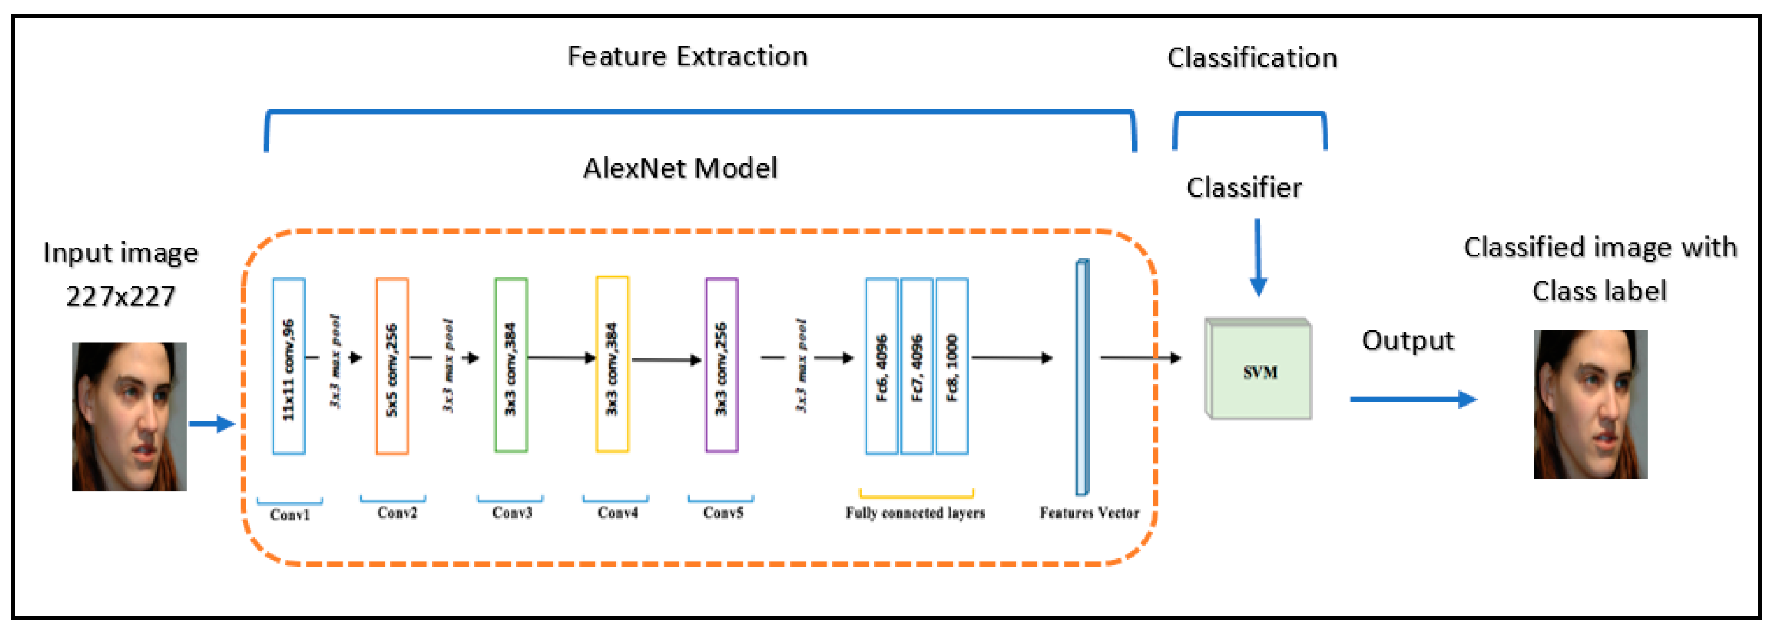

Figure 1. Alex Net Convolutional Neural Networks

2. **Regression models** in age detection predict continuous age values instead of discrete categories. Common techniques include:

Multiple Linear Regression (MLR): This method constructs models to estimate age based on multiple independent variables, often yielding high accuracy in age prediction across various datasets

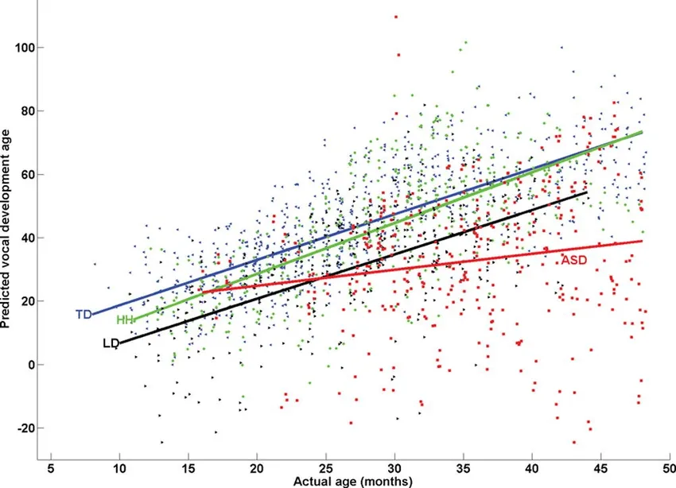

Figure 2: Multiple linear regression model predictions for individual observations (https://corporatefinanceinstitute.com/resources/data-science/multiple-linear-regression/)

**Polynomial Regression**: This technique fits a polynomial equation to the data, allowing for more complex relationships between features and age.

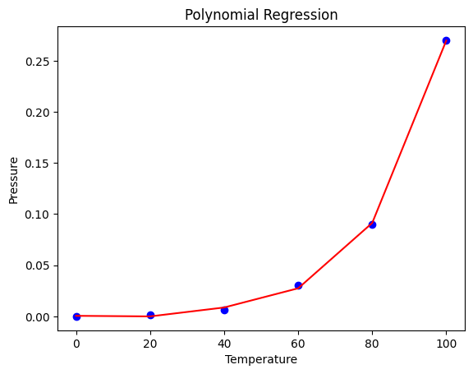

Figure 3. Implementation of Polynomial regression

Support Vector Machine (SVM): This is a sophisticated machine learning technique that may be used for linear or nonlinear classification, regression, and outlier detection. SVMs are useful for a range of applications, including text classification, image classification, spam detection, handwriting identification, gene expression analysis, face detection, and anomaly detection. SVMs are versatile and efficient in a wide range of applications because they can handle high-dimensional data and nonlinear relationships.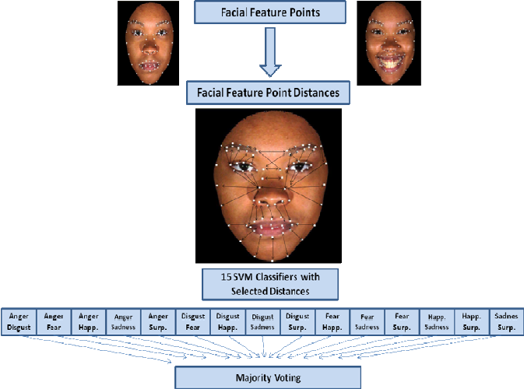

Figure 4. SVM classifier system used for facial expression recognition.

3. **Ensemble Models**: These combine multiple learning algorithms to improve age prediction accuracy. Examples of the algorithm include:

Random Forest: Using random forests is one method of obtaining predictive models for classification and regression. Binary decision trees, such as CART trees, are implemented using this technique. Basically, the strategy generates multiple predictors and then pools their individual predictions, rather than attempting to find an optimum solution all at once. Make use of this feature to regress or categorize a sample of data based on qualitative or quantitative characteristics. Classification (variable qualitative response): Using quantitative and/or qualitative explanatory variables, the method predicts the affiliation of observations (observations, individuals) to a class of a qualitative variable.

In regression analysis, also known as variable continuous response, the approach forecasts a dependent variable's value by utilizing both quantitative and/or qualitative explanatory factors. In Fig. 2, the Random Forest classifier is shown. Each class vector is created by averaging the percentage of various training example classes at the leaf node where the instance in question is located, and then calculating this percentage over all trees within the same forest.

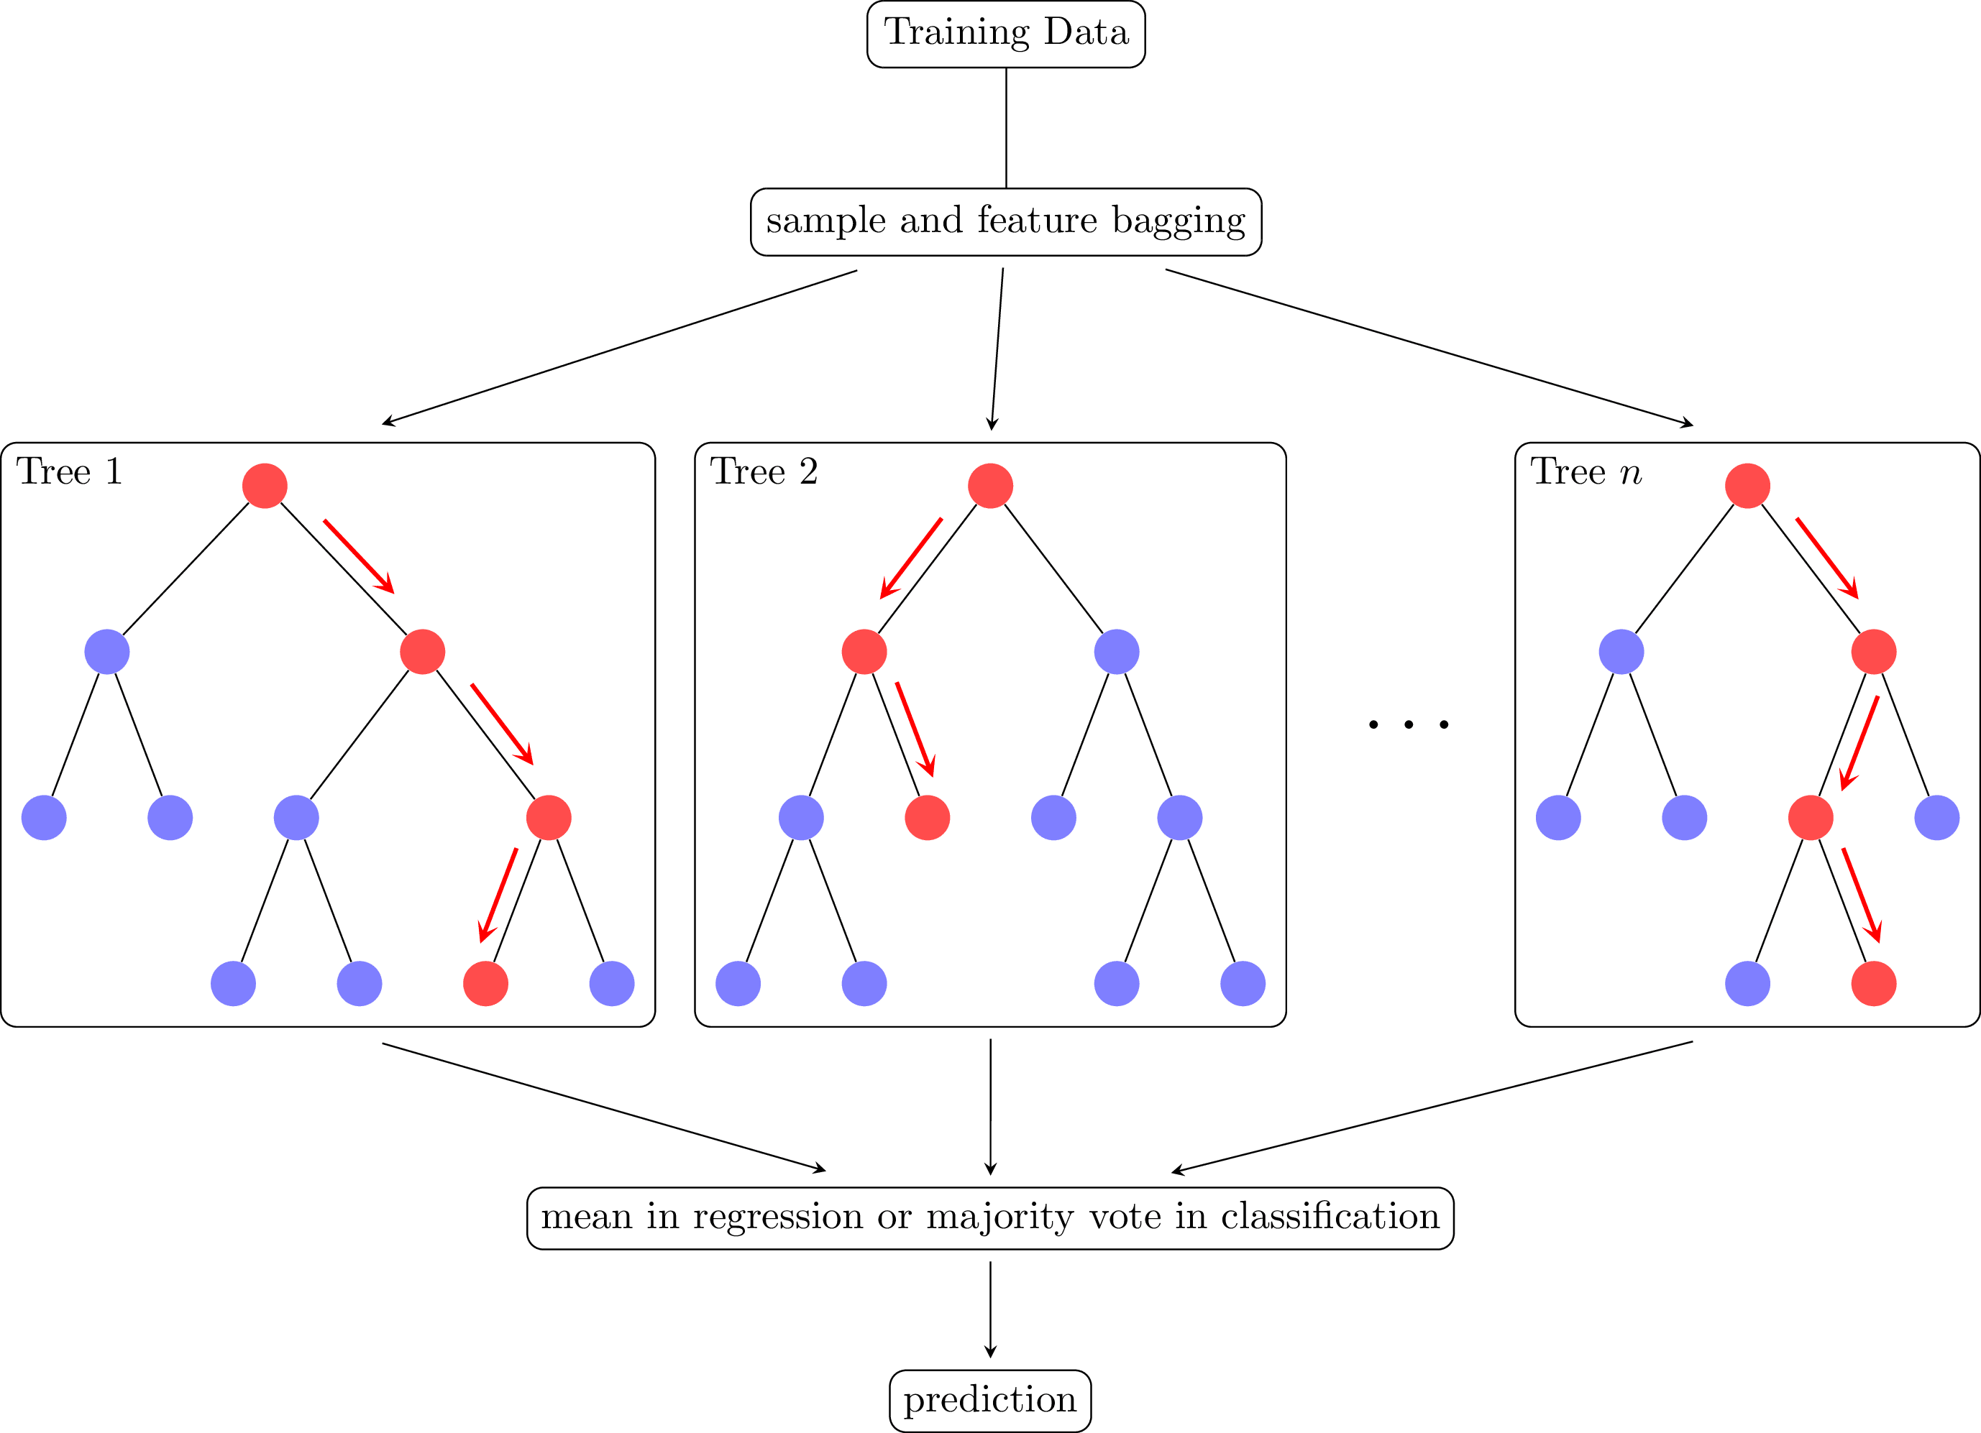

Fig 5. Illustration of Random Forest Classifier

Gradient Boosting Machines (GBMs) are a powerful ensemble learning technique that combines multiple weak models, often decision trees, to create a strong predictive model. The key idea behind GBMs is to sequentially build models that correct the errors of previous models, gradually improving the overall prediction performance.

**2.3 REVIEW OF MOBILE- BASED AI APPLICATIONS**

**Mobile AI technologies**

Mobile AI technology have advanced to the point where substantial artificial intelligence capabilities can be delivered straight to mobile devices. These technologies improve user experiences by allowing for real-time processing, personalization, and better functionality without relying substantially on cloud services.

• In terms of mobile device technology, edge computing signifies a substantial departure from conventional cloud-based AI processing. Edge computing allows real-time data processing, lowers latency, improves privacy, and boosts the effectiveness of AI applications by moving compute and data storage closer to the source of data generation, which is mobile devices. With the ability to carry out sophisticated AI activities locally on smartphones, tablets, and other mobile devices, this paradigm is especially revolutionary for mobile AI.

• AI accelerators are specialized hardware components that can perform complicated AI computations more efficiently than general-purpose CPUs. These accelerators offer sophisticated AI capabilities in mobile devices while preserving energy efficiency and performance. Mobile devices often include specialized hardware, such as GPUs, NPUs (Neural Processing Units), or DSPs (Digital Signal Processors), to accelerate AI computations efficiently.

• Real-time speed is crucial for mobile AI apps, since consumers want immediate response and seamless interactions. Real-time performance requires refining different components of AI models, hardware, and software to ensure quick and efficient processing. Here's an in-depth look at how real-time performance is achieved and its importance in mobile applications.

Mobile AI can carry out real-time operations such as facial recognition, object identification, language translation, and augmented reality applications. This is critical for applications that need quick feedback.

**2.3.2 Existing AI-Based Applications**

Artificial intelligence (AI) has become a pivotal element in various applications, supporting a broad spectrum of features such as facial recognition, emotion detection, health monitoring, and augmented reality (AR). These applications harness advanced AI algorithms to deliver seamless and responsive user experiences. Understanding the parallels between these applications and age detection methods is essential when designing an AI-powered age detection system. This project report examines existing AI applications, their underlying technologies, and the insights they offer for age detection.

AI Applications Utilizing Facial Recognition

Facial recognition technology is employed in numerous applications across different platforms. For instance, Apple Face ID enhances security by combining a depth-sensing camera with neural networks to facilitate device unlocking and payment authorization. Similarly, Google Photos employs face recognition to automatically organize photos, detecting and categorizing images of the same individual.

These systems utilize 3D depth sensing to capture detailed facial traits and convolutional neural networks (CNNs) to extract and compare these features. Secure enclaves are employed to store and analyze facial data, ensuring both precision and secure data management. The emphasis on real-time processing and effective functioning under varied scenarios is crucial for these technologies.

AI Applications Utilizing Emotion Detection

Emotion detection is another significant application of AI, extending its utility beyond mobile devices. Affectiva, for example, analyzes facial expressions to detect emotions, which is applied in market research, vehicle safety, and personal health monitoring. Replika, an AI chatbot, uses emotion detection to adapt its responses, creating empathetic user experiences.

This technology employs computer vision to identify microexpressions and facial muscle movements, and machine learning models to classify emotions such as happiness, sorrow, and anger. Natural language processing (NLP) further enhances the system's ability to understand and adapt responses based on detected emotions.

AI Applications Utilizing Augmented Reality

Augmented reality (AR) applications also benefit significantly from AI. Pokémon Go uses AR to overlay virtual Pokémon onto real-world environments, requiring real-time scene analysis. Snapchat employs AR filters and lenses to track and modify users' facial features dynamically.

AR applications use computer vision to detect and monitor real-world objects and facial features, and real-time rendering to overlay digital content on live camera feeds. Machine learning models are used to enhance AR effects and ensure realistic interaction with the environment.

Both AR and age detection technologies necessitate real-time processing, high accuracy in feature detection, and the ability to handle various environmental conditions and user interactions. Advanced computer vision techniques are integral for analyzing facial features, which is essential for both AR and age detection applications.

Understanding these diverse AI applications provides valuable insights into developing robust AI-powered age detection systems. By leveraging the techniques and technologies used in facial recognition, emotion detection, and augmented reality, the design of age detection systems can be optimized for various use cases beyond mobile platforms, ensuring enhanced performance and user experience.

**2.4 CHALLENGES IN AI BASED APPLICATION**

Accuracy Variability: The accuracy of age estimation algorithms can vary significantly based on factors such as image quality, demographic characteristics, and the specific algorithm used. For instance, the National Institute of Standards and Technology (NIST) found that no single algorithm performs uniformly well across different populations, leading to potential inaccuracies in age predictions.( https://www.aei.org/technology-and-innovation/the-challenges-of-age-prediction-where-current-technology-falls-short/)

Gender Disparities: Research indicates that age detection algorithms often exhibit higher error rates for female faces compared to male faces. This inconsistency raises concerns about the fairness and reliability of these technologies across different genders, potentially leading to biased outcomes in applications where accurate age estimation is critical.

Age-Related Inaccuracies: Certain age ranges, particularly very young or older individuals, are more challenging for age estimation algorithms to assess accurately. This limitation can pose significant risks in contexts that require precise age verification, such as protecting minors from inappropriate content.

Technical Limitations: Challenges such as different lightening conditions, head-pose variations, image resolution, and facial modifications can hinder the performance of age detection algorithms. These factors can introduce noise into the data, complicating the model's ability to make accurate predictions. (ElKarazle et al.,2022)

Ethical Concerns: The use of AI in age detection raises ethical questions regarding privacy, consent, and the potential for misuse. There are concerns that these technologies could infringe on individual rights, particularly for vulnerable populations like children and the elderly. (Charlene et al., 2022)

**2.5. REVIEW OF RELATED WORKS**

Singh, O., & Mourya, K. (2024) conducted research on gender and age detection using machine learning algorithms. Their study reviewed recent advancements in machine learning techniques that have significantly impacted the field of computer vision, particularly in detecting gender and age from visual data. They provided a comprehensive analysis of two prominent machine learning models—Support Vector Machines (SVM) and Convolutional Neural Networks (CNN)—focusing on these detection tasks. The research systematically examined the performance of SVM and CNN across various datasets and explored their applicability in real-world scenarios, including advertising, security, healthcare, and surveillance.

The authors demonstrated that CNN-based models generally achieve higher accuracy and robustness compared to SVM models due to their ability to learn hierarchical features from raw images. However, SVM models offer advantages in computational efficiency and interpretability. The research underscored the critical role of gender and age detection across multiple fields, including personalized marketing, enhanced security protocols, and refined healthcare diagnostics and treatments. Their study contributed to the ongoing discourse on leveraging machine learning advancements for societal benefits and emphasized the importance of selecting the most suitable algorithms for specific gender and age detection applications.

Savchenko, A. V. (2024), conducted research on Autoface, focusing on how to obtain a neural network-based facial feature extractor in less than 10 minutes. The study addressed the significant challenges posed by the diverse processing capabilities of various mobile and edge devices in creating a universal neural network architecture for extracting facial embeddings. The authors applied automated machine learning techniques to design a neural network optimized for performance on specific devices.

This study supports the approach of involving a genetic algorithm to select the optimal subnetwork from a Supernet, utilizing a surrogate binary classifier to estimate the expected accuracy of candidate subnetworks without directly assessing them on a validation set. This method enabled the development of the most computationally efficient and accurate model in TensorFlow Lite format within less than 10 minutes, tailored to specific device and latency constraints. The study also included the development of an Android demo application to showcase the potential of the designed neural networks. Experimental results demonstrated the versatility of the proposed approach, which was capable of extracting deep embeddings for various tasks such as face verification and facial expression recognition across different devices, including smartphones and Raspberry Pi single-board computers. The models achieved real-time processing of facial images and significantly surpassed the accuracy of existing lightweight networks.

Wang, H., Sanchez, et al. (2024) conducted a research to address the challenge of collecting cross-age facial images, which are typically difficult and costly to obtain. This scarcity results in relatively small, noise-free age-oriented datasets compared to larger facial datasets commonly used. Furthermore, in real-world scenarios, acquiring images of the same individual at different ages is often impractical or impossible. These factors contribute to a shortage of supervised data, limiting the effectiveness of supervised methods for age-invariant face recognition—a crucial task for applications in security and biometrics.

To tackle this issue, the authors proposed a novel semi-supervised learning approach called Cross-Age Contrastive Learning (CACon). Their project focused on leveraging the identity-preserving capabilities of recent face synthesis models to introduce a new contrastive learning method, which incorporates an additional synthesized sample from the input image. Alongside CACon, they developed a new loss function designed to facilitate contrastive learning on a triplet of samples.

They demonstrated that their method achieves state-of-the-art performance in homogeneous-dataset experiments on several age-invariant face recognition benchmarks. Additionally, their approach significantly outperforms other methods in cross-dataset experiments, highlighting its robustness and versatility.

**2.6 GAPS IDENTIFIED IN THE LITERATURE**

In the Literature being reviewed, there are several gaps identified on the development of Age detection systems. One of the gaps identified is Limited Dataset Diversity. Many age detection algorithms are trained on datasets with little ethnic, gender, and age diversity. When applied to real-world settings, this may result in distorted performance. According to research, models frequently underperform on underrepresented demographic groups, raising questions about fairness and accuracy. (Al-Shannaq et al.,2019)

AI-based age detection systems also face a fundamental challenge in accurately assessing and accounting for the diverse impacts of aging on human facial features and other biometric traits. Aging introduces gradual and intricate changes influenced by various external factors such as lifestyle, genetics, and environmental conditions. These changes are non-linear and can differ significantly among individuals and demographic groups. Current algorithms often struggle to capture and interpret these complexities, leading to inaccuracies in age estimation.

Another potential gap in the literature related to age detection is Age Invariance. A notable research gap in AI-based age detection systems is their limited ability to achieve age invariance the capability to maintain consistent performance across different age groups. Age invariance is crucial because age-related changes in facial features or other biometric traits can significantly impact the accuracy of age detection models. The challenge is compounded by the fact that aging affects individuals differently, influenced by genetic factors, lifestyle choices, and environmental conditions.

The current state of several literature studies have identified that most AI models are trained predominantly on middle-aged adult faces, resulting in a performance preference against younger and older age groups. For instance, a model trained on a dataset with a majority of individuals aged 20-40 may not perform well when applied to faces of children or the elderly. This preference leads to inaccuracies and decreased reliability in real-world applications where a broader age range is encountered.

In conclusion, this project is addressing several critical gaps identified in the literature on age detection. By focusing on enhancing dataset diversity, accounting for environmental factors, reducing algorithmic inaccuracy, integrating multi-modal data, enabling real-time processing, and considering ethical implications, this project aims to significantly improve the accuracy, fairness, and applicability of age detection technologies.

**2.7 SUMMARY OF REVIEWED WORKS**

|  |  |  |  |  |
| --- | --- | --- | --- | --- |
| **Paper Tittle and Authors** | **Problem Solved** | **Methodology** | **Result** | **Limitations** |
| **Improvising Age Verification in Canada**  **Adib, A., Zhu, W. P., & Ahmad, M. O. (2024** | Age verification, which is a mandatory legal requirement for delivering certain age-appropriate services or products, has recently been emphasized around the globe to ensure online safety for children. | The article stated that the rapid progress of artificial intelligence had enabled the recent emergence of advanced age-verification technologies, with a focus on utilizing biometrics. | It emphasized that effective collaboration among academia, government, and industry entities could address the increasing need for age-verification services in Canada, all while prioritizing a user-centric approach. | However, successful deployment and mass acceptance of these technologies are significantly dependent on the corresponding socio-economic and regulatory context. |
| **2.**  **Large age verification by learning GAN synthesized prototype representations**  **Jena, S., Balabantaray, B. K et al. (2024)** | This paper aims to perform face verification on the LAG dataset by learning the large intra-class variance posed by aging | They mentioned that age-related face verification methodologies could be categorized broadly into two groups. They explained that the first approach involved discriminative models trained on extensive datasets using deep convolutional neural networks (DCNN), citing references such as El Khiyari and Wechsler (2016), Wang et al. (2018b), El Khiyari et al. (2017), and Sajid et al. (2018). Additionally, they noted that the second approach focused on generative methods to create age-synthesized data for training.­ | They explained that for a fair comparison, they had applied a backbone feature extractor, specifically the InceptionResnetv1 model pretrained on the CASIAWebFace dataset (Yi et al., 2014), across all scenarios mentioned. They specified that they kept the embedding dimension consistent at 512 for all loss functions based on metric learning, and resized the images to dimensions of 160x160 pixels. | The problem becomes quite compelling with the consideration of large age gaps |

**­**

|  |  |  |  |  |  |  |  |  |  |  |  |  |  |  |  |  |
| --- | --- | --- | --- | --- | --- | --- | --- | --- | --- | --- | --- | --- | --- | --- | --- | --- |
| 3.Cross Age contrastive learning for Age In-variant face recognition.Wang, H., Sanchez et al (2024) | | | | Age-invariant face recognition (AIFR) aims to recognize the identity of subjects regardless of their age. | | | | A method named Cross-Age Contrastive Learning (CACon) was introduced as a solution to address the AIFR issue in a semi-supervised manner. They outlined that the approach involved leveraging contrastive learning principles to enhance the similarity between features derived from a pair of augmented samples originating from the same input image. | | | Most existing AIFR methods attempt to solve the problem under supervised settings. | | However, cross-age facial images of the same subject are extremely difficult to collect. As a result, existing noise-free age-oriented face datasets are small in size, with limited samples per subject, which could degrade the performance of supervised approaches | | | |
| 4.[Additional Security in ATM Transactions Using Face Recognition and OTP Verification](https://ieeexplore.ieee.org/abstract/document/10459580/) **Mohite, A et al (2024)** | | | | This project presents an innovative ATM security system that seamlessly integrates face recognition authentication and OTP (One-Time Password) verification, significantly enhancing security in financial transactions. | | | They explained that the system employs a robust yet adaptable method, starting with users inputting their username and password. Following this step, their facial image is captured and subjected to analysis using the LBPH algorithm. | | | | It was outlined that in scenarios where an alternative access method is required, such as withdrawals facilitated by trusted individuals, the system seamlessly switches to OTP verification. If facial recognition encounters an error, an OTP is generated and sent to the user's registered mobile number, allowing authorized parties to carry out transactions. | | |  | | | |
| **5.**  **Face Recognition system for**  **Identity Theft protection**  **Banne, S. S., Shaikh, R. A., Shimpi, M. S., Maniyar, S. S., & Maurya, V. S (2024)** | The primary objective of this project is to develop a facial recognition system that uses liveliness to detect and predict the user, it helps to authenticate the user by scanning facial gestures, motion and eye blinking. This system aims to enhance the privacy and authenticity of the user | | | | | Using the CNN algorithm | | | By leveraging the capabilities of facial recognition algorithms, the project aims to develop a system that can accurately and efficiently verify user identities, preventing fraudulent access to paid course materials. | | | Face recognition systems involve intricate algorithms and technologies such as machine learning, computer vision, and data processing. Implementing such a system may require a high level of technical expertise and resources that might not be readily available or feasible for a school project. | | | |
| **6.**  **Face Recognition for Automatic Border Control**  **Hidayat, F., Elviani et al (2024)** | This research aims to provide in-depth insight and assist researchers and practitioners in developing large-scale facial detection systems for automatic border control. | | | | | The primary objective of the Systematic Literature Review (SLR) was to identify and analyze the current state-of-the-art (SOTA) in the development of a facial identification system using big data. | | | Various types of attacks and challenges have emerged in border security that utilize facial biometric authentication | | | Face recognition utilizes facial data as a verification instrument; this, of course, raises numerous privacy and security concerns. Even though facial recognition technology can essentially function as a security system, this can give rise to concerns concerning privacy ethics. | | | |
| **7.**  **Facial Recognition**  **Technology: College Student’s Perspectives in China**  **Wu, Y. (2024)** | This study explores the perspectives of college students aged 18-25 in China regarding Facial Recognition Technology (FRT)  Amidst an era of rapid technological advancements and privacy concerns, this paper examines the nuanced views of young adults on the deployment and implications of FRT. | | | | The initial phase of this study involved a comprehensive survey | | | | The Survey  Revealed a high awareness of FRT’s diverse applications, particularly in identity authentication | | | Privacy emerged as a significant concern in the discussions.  While some students consider cameras necessary for security, others are wary of the it potential to intrude on personal privacy. | | |
| **8.**  **Digital Criminal Biometric Archives (DICA) and Public Facial Recognition System (FRS) for Nigerian criminal investigation using HAAR cascades classifier technique**  **Ndubuisi, O. J., Adene et al (2024)** | The focus of this paper is to develop an automatic criminal investigation system that can identify criminals based on their faces and produce real-time digital archives about them. | | | | This technique serves as a method for progressively developing an item. They emphasized delving extensively into the specific system requirements for the DICA-FRS, including considerations such as the suitable programming language and version, system features, usability, testing, and readiness for production deployment, among other factors. | | | | The first stage which is face detection as explained above is a step in face recognition system of DICA. The second stage is the face encodings, using the Euclidean distance **Eu** calculation. | | | While the HAAR cascades classifier technique has been widely used in facial recognition, it may have limitations in accurately detecting faces under varying conditions such as different lighting, facial expressions, and occlusions. This could impact the system's overall performance and reliability. | | |
| **9.**  **FACE RECOGNITION: IN HEALTHCARE.**  **Kurdekar, S. S et al (2024)** | | | The paper highlights the potential for improved accuracy and efficiency in patient identification and access control, as well as its role in monitoring physiological parameters and facilitating remote patient monitoring | This study delves into the burgeoning field of machine learning algorithms applied to facial expression recognition, with a primary focus on the convolutional neural network (ConvNet) deep learning approach | | | | | Face recognition technology can enhance patient identification processes in healthcare settings, reducing errors associated with traditional methods like ID cards or patient records. This could lead to more accurate treatment and better patient outcomes. | | | Integrating face recognition technology with existing healthcare systems and workflows can be complex and may require significant investment in terms of time, resources, and technical expertise. Compatibility issues with legacy systems could pose barriers to implementation. | | |
| **10.**  **Enhanced facial recognition attendance system for educational institutions with opencv.**  **Varshini, P. U et al (2024)** | | | The primary goal of the project is to automate the attendance process, eliminating the need for manual data entry and reducing the administrative burden on faculty members and staffs. | The data collection process involves gathering images of students' faces for enrolment in the system. Initially, a dataset of facial images is created by collecting images of each student. | | | | | The project achieved robust facial recognition and attendance tracking capabilities. Through extensive experimentation and validation, it demonstrated the effectiveness of the implemented algorithms in accurately identifying and recording attendance in real-time. | | | Improving Recognition Accuracy: Continuously refining the face recognition algorithms to achieve higher accuracy rates, particularly in challenging conditions such as varying lighting, facial expressions, and occlusions. | | |
| **11.**  **Masked face and gender identification**  **Using CAFFE-modified mobileNetv2 on photo and real time video images by transfer learning and**  **Deep learning**  **Kumar, B. A et al (2024).** | | | One of the most challenging factors related to masked face age and gender identification (MFAGI) is developing a technique to quickly carry out identification and maintain accuracy without needing people to remove their masks | The dataset for this method includes images of people of different ages and genders, featuring various facial features, emotions, camera angles, backgrounds and lighting. | | | | | Age and gender prediction performance improves significantly with CNN feature representation training (Wanga & Davies, 2019). Modern biometric and facial identification research focuses on gender and age prediction for better future predictions and a better understanding of people. | | | Studies recommend fundamental changes to visual identification systems and show that balanced datasets may not provide fair predictions (Wang, Zhao, Yatskar, Chang, & Ordonez, 2019). | | |
| **12.**  **Autoface:**  **How to obtain**  **Neural network based**  **Facial feature extractor in less than 10 minutes.**  **Savchenko, A. V. (2024** | | | A typical example is authentication with the face unlock on a smartphone, which should work reliably even if it is not connected to the network. | | The face processing tasks mentioned are addressed by utilizing a deep neural network (DNN) pretrained on facial datasets such as WebFace, MS-Celeb-1M, or VGGFace/VGGFace2. | | | | This paper describes a novel AutoFace technology for quickly designing device-specific facial embeddings on offline mobile systems. Our method is effective if it is required to extract facial features in real-time on multiple mobile or edge devices. | | | One of the most challenging problems in many mobile applications is offline facial analysis in unconstrained environments | | |
| **13.**  **Application of AI**  **Multilevel pain assessment using facial images: Systematic Review and meta-analysis.**  **Huo, J., Yu, Y., Lin, W., Hu, A., & Wu, C. (2024).** | | | The purpose of this systematic review and meta-analysis was to investigate the diagnostic performance of artificial intelligence models for multilevel pain assessment from facial images. | | The performance of these studies was assessed by metrics including sensitivity, specificity, log diagnostic odds ratio (LDOR), and area under the curve (AUC). | | | | The facial feature extraction method can be categorized into 2 classes: geometrical features (GFs) and deep features (DFs). One typical method of extracting GFs is to calculate the distance between facial landmarks. | | | This study is limited for several reasons. First, insufficient data were included because different performance metrics (mean standard error and mean average error) were used in most studies, which could not be summarized into a contingency table | | |
| **14**  **Deep learning techniques for biometric security: A systematic review of presentation attack detection systems**  **Shaheed, K et al**  **(2024)** | | | [Biometric technology](https://www.sciencedirect.com/topics/engineering/biometric-technology), including finger vein, fingerprint, iris, and face recognition, is widely used to enhance security in various devices. In the past decade, significant progress has been made in improving [biometric](https://www.sciencedirect.com/topics/computer-science/biometrics) systems, thanks to advancements in [deep convolutional neural networks](https://www.sciencedirect.com/topics/computer-science/deep-convolutional-neural-networks) (DCNN) and [computer vision](https://www.sciencedirect.com/topics/engineering/computervision) (CV), along with large-scale training datasets. | | Material & performance metric for PAD method Recent advancement of deep learning algorithm in presentation attack detection of finger vein, finger print, iris and faceTechnical problem and solution & best results in existing DL-based PAD methods | | | | DL-PAD techniques have made significant improvements in several biometric modalities. However, this survey's findings indicate a critical need for DL-based models to be evaluated using cross-modality datasets. | | | Modern biometric modalities, such as finger vein, fingerprint, face, and iris recognition methods, are susceptible to presentation attacks, posing a significant challenge to their security. | | |
| **15** Sensor-based authentication in smartphone: A systematic review **Shaheed, K. et al (2024)** | | | securing the smartphone’s accessibility from unauthorized people became an extremely essential. | | Utilizing biometric methods can efficiently prevent unauthorized access to smartphone internal resources and identity theft | | | | Biometric based authentication solutions are promising techniques to replace traditional authentication mechanisms. | | | Most of the challenges are related to data accessibility, usability of authentication, data security, data collection, behavioral biometric, simulation scenarios, and authentication methods. | | |
| **16**  **Gender And Age Detection Using Machine Learning Algorithm**  **Singh, O., & Mourya, K. (2024).** | | | This paper presents a comprehensive analysis of two popular machine learning models, Support Vector Machines (SVM) and Convolutional Neural Networks (CNN), for gender and age detection tasks. | | CNN (Convolutional Neural Network) is a type of artificial neural network that is widely used for image or object identification and classification. | | | | CNN;  By establishing an accurate and efficient age and gender categorization with less computing time, the suggested method performs well. The input picture for the proposed system is either chosen from the dataset or perhaps sent in real time via the camera. To increase the effectiveness of the matching process, the source picture is pre-processed. | | | A CNN can have many hidden layers and perform calculations to extract features from the image | | |
| **17**  **Data privacy and security in IT: a review of techniques and challenges**  **Farayola, O. A.et al (2024)** | | This review provides a comprehensive review of techniques and challenges surrounding data privacy and security in information technology (IT) systems. | | Symmetric cryptography, also known as secret-key cryptography, employs a single key for both encryption and decryption processes | | | | | | This includes regularly assessing risks, implementing robust security controls, and staying abreast of emerging threats and vulnerabilities | | Failure to adequately protect data can result in financial losses, reputational damage, and legal consequences for organizations and individuals alike. | | |
| **18**  **Machine learning assessment of dental age classification based on cone-beam CT images: a different approach**  Dogan, O. B.et al. (2024) | | This study aims to use ML algorithms to evaluate the efficacy of pulp/tooth area ratio (PTR) in cone-beam CT (CBCT) images to predict dental age classification in adults. | | Support vector machine, classification and regression tree, and random forest (RF) models for dental age classification were employed. | | | | | | The models’ performances were found to be low. The models’ highest accuracy and confidence intervals were found to belong to the RF algorithm. | | According to the results, models were found to be low in performance but were considered as a different approach. | | |
| **19.**  **A systematic analysis of machine learning algorithms for human emotion detection using facial expression**  **Kumar, A. (2024)** | | this study is dedicated to refining the process of identification of seven specific emotions (joy, sorrow, terror, rage, surprise, disgust and neutrality). | | The established approaches to the construction of emotion detection systems were examined centered on expressions of human face. | | | | | | This study assesses experimental studies and analytical articles for emotion recognition, as well as a variety of other approaches that have been applied or investigated. | | Due to the fact that humans immediately perceive facial movements for all intensive purposes, recognition of expressions by computer is indeed a task | | |
| **20.**  **Identifying People’s Faces in Smart Banking Systems Using Artificial Neural Networks**  **Nosrati, L. et al. (2024)** | | The security and authentication of users have become increasingly crucial with the growth of mobile banking and the rise in user numbers. To enhance and facilitate this, intelligent facial authentication has been introduced as a fresh and potent technology | | They indicated that their focus lies in the development of a face authentication system. They stated that the study introduces a hybrid enhanced method for machine learning systems, aiming to tackle security detection and face verification issues.. | | | | | | To test the proposed approaches, a set of images taken from the AR face database and mobile camera frames for different people have been used. 15 photos with different facial expressions and light changes are considered for each person. | | The main problem of this proposed method is that it does not make any decisions for unlabeled individuals that have not been introduced before. | | |

**CHAPTER THREE**

**METHODOLOGY**

**3.1 Research Method**

This research centers on the development and evaluation of an AI-based age detection system, situated within the domains of Computer Vision and Machine Learning. The goal of the system is to accurately determine and verify an individual's age through biometric data, such as facial images. The focus is on improving age estimation, gender accuracy and ensuring fairness in applications like security, user verification, and content access control.

The development of the age verification system involves a structured approach, starting with a detailed planning phase where the system’s objectives, functionalities, and design specifications are defined. The project is broken down into specific tasks, each addressing a particular aspect of the age detection process, including data collection and model training. The system utilizes advanced machine learning models and computer vision techniques for age detection. These models are trained on extensive and diverse datasets to improve their accuracy and adaptability across various age groups. State-of-the-art algorithms in age estimation are applied to analyze facial features and other biometric indicators. Development tools and frameworks are selected based on their suitability for the project requirements. Machine learning libraries such as Argparse and OpenCV are used to develop and refine the age detection models.

In conclusion, this research aims to build an AI-based age verification system by integrating cutting-edge machine learning techniques with practical application frameworks. The objective is to deliver a robust and accurate system capable of meeting the needs of various real-world applications, including secure age verification and controlled content access.

**3.2 Research Design Layout**

Designing the research layout for an AI application focused on age verification requires a clear and methodical approach to structuring the research plan and methodology. This process begins with a review of existing methods, where current technologies and approaches for age verification using AI are summarized. This review helps in understanding the current state of the field and highlights how the proposed research will build upon or differ from existing work.

Following this, the research design should identify limitations and gaps in the current methods and literature. This involves pinpointing specific areas where existing approaches fall short and explaining how the new research will address these shortcomings. By addressing these gaps, the research aims to contribute novel insights and improvements to the field.

However, theoretical frameworks play a crucial role in informing the research design. It is essential to discuss relevant theoretical concepts or models that underpin the study. These frameworks provide a foundation for understanding the mechanisms behind age verification technologies and guide the development and implementation of the research methodology.

Finally, the overall research approach must be defined. This includes specifying whether the research will be experimental, observational, or utilize another methodology, and providing a rationale for the chosen approach. The rationale should explain why the selected approach is the most suitable for addressing the research questions and objectives. This structured and organized plan ensures that the research is well-founded and capable of producing meaningful and reliable results.

**3.3 Research Instrument/tools**

In developing an AI application for age verification, a range of research instruments and tools are employed throughout the research and development stages. These tools facilitate various aspects of the process, including data collection, preprocessing, model training, and evaluation.

Web scraping tools, such as BeautifulSoup and Scrapy, are utilized to gather publicly available images or documents that contain relevant age-related information. APIs are employed to access external databases or online repositories, which provide essential identity documents and additional age-related data. Data annotation tools, including LabelImg, are crucial for labeling images with age information and annotating textual data with relevant age details.

For data manipulation and cleaning, Python libraries such as NumPy and Pandas are used. OpenCV is essential for image preprocessing tasks such as resizing, normalization, and augmentation. Natural Language Processing (NLP) libraries, such as NLTK and SpaCy, assist in text preprocessing and feature extraction from documents.

In the domain of model development, frameworks like TensorFlow and Keras are widely used for constructing and training deep learning models, including Convolutional Neural Networks (CNNs) designed for image-based age estimation. PyTorch is another prominent framework suitable for both image and text-based tasks, providing flexibility in model building.

Traditional machine learning tasks, such as regression and classification, may be performed using Scikit-learn, which offers a range of tools for model development. Evaluation of model performance is supported by metrics libraries that provide functions for calculating accuracy, precision, recall, and F1-score. Cross-validation tools, also available in Scikit-learn, help assess model performance across various data subsets, while confusion matrix tools are employed to visualize and analyze discrepancies between model predictions and ground truth labels.

These instruments and tools collectively support the comprehensive development and evaluation of an AI-based age verification system, ensuring strong and accurate performance throughout the research process.

**3.4 Data Collection**

Data collection for an AI-based age verification application necessitates the acquisition of relevant datasets that encompass age-related information. The nature of the data collected is contingent upon the specific objectives of the application, which may involve age verification through photographs, identity documents, or other sources.

A diverse collection of photographs is essential, including images of individuals across various age groups. These photographs can be obtained from public databases, social media platforms (where permissions are secured), or through collaborations with organizations that provide access to such data. This diversity ensures that the AI model is trained on a wide range of age-related visual features.

In addition to photographs, it is crucial to collect scans or images of identity documents such as driver's licenses, passports, and birth certificates. These documents contain explicit age information and serve as a reference for validating the accuracy of the AI application. By comparing the age data from these documents with the model's predictions, the system's reliability can be assessed.

Furthermore, leveraging publicly available datasets that include age annotations or metadata can enhance the robustness of the age verification system. It is imperative to ensure that the use of these datasets complies with data privacy regulations and adheres to ethical standards. This approach not only supports the development of a more accurate AI model but also aligns with legal and ethical guidelines in data handling.

**3.4.1 Datasets for Age Detection**

Several datasets are commonly used in age detection projects, each with unique characteristics.

Here are just few of the datasets:

**1. FGNet**

FGNet is a dataset for age estimation and face recognition across ages. It is composed of a total of 1,002 images of 82 people with age range from 0 to 69 and an age gap up to 45 years.

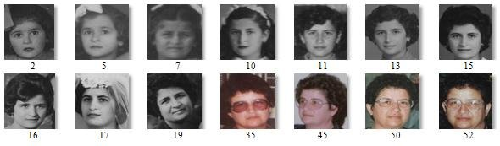

Figure 6. Sample images from FGNET dataset with age values

**2. MORPH Dataset**

This dataset contains 55,134 facial images of 13,617 subjects aged 16 to 77. It is useful for studying age progression and regression in facial images .

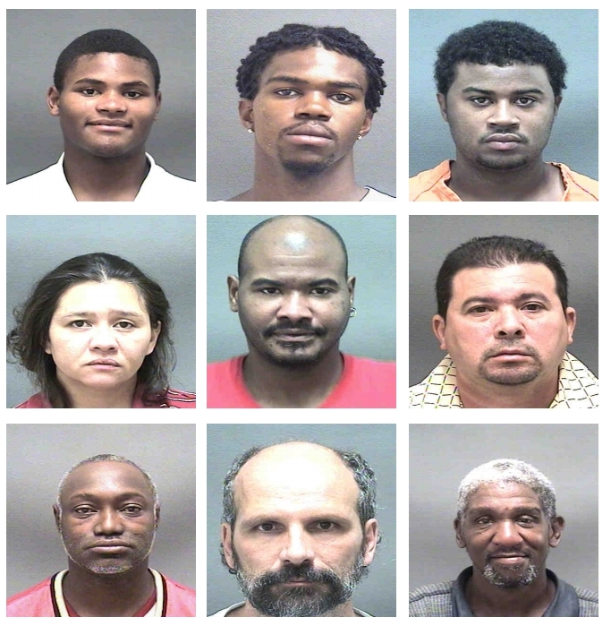

Fig 7. Some facial samples of MORPH dataset

**3.UTKFace Dataset**

This is a large-scale face dataset with long age span (range from 0 to 116 years old). The dataset consists of over 20,000 face images with annotations of age, gender, and ethnicity. The images cover large variation in pose, facial expression, illumination, occlusion, resolution, etc. This dataset could be used on a variety of tasks, e.g., face detection, age estimation, age progression/regression, landmark localization, etc.

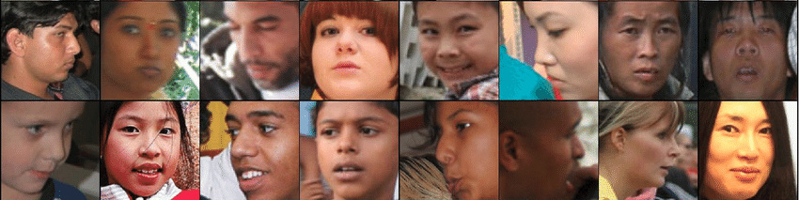

Fig 8. Sample of images taken with different pose and angles for UTK dataset

**3.5 Data Processing:**

* Data preparation is a necessary first step in any data analysis or machine learning channel. This phase entails thorough data cleaning and annotation to assure data integrity and suitability for future modeling.
* Data cleaning comprises discovering and resolving flaws, inconsistencies, and redundancies in a dataset. This process frequently includes the reduction of duplicate data points, the correction of mislabeled instances, and the imputation or removal of missing information. These efforts improve data quality, lowering the probability of erroneous findings drawn from future analysis.
* Annotation, on the other hand, is the process of applying meaningful labels or tags to data items in order to provide context and improve understanding. For example, with picture datasets, items inside images may be tagged, whereas text data may be categorized based on certain criteria. Accurate and consistent annotation is required for effective training of machine learning models.
* Data Augmentation techniques including rotating, flipping, and cropping photographs are used to artificially boost the dataset's diversity. This helps to increase the model's resilience and generalizability.
* Partitioning is a technique that involves dividing the data into training, validation, and test sets. The typical split is 70-80% teaching, 10-20% validation, and 10-20% testing.

**3.6 Data Training**

The training phase involves the application of the collected and preprocessed dataset to develop the age detection model. During this phase, the model is exposed to the training dataset, allowing it to learn and internalize patterns and features that correlate with age. The training process is meticulously monitored through the use of key performance metrics such as loss and accuracy. These metrics provide insights into how well the model is learning and adapting to the data. Loss, in this context, refers to the difference between the predicted ages and the actual ages in the training set. By minimizing this loss, the model improves its accuracy, which is the proportion of correct predictions out of all predictions made. Monitoring these metrics is crucial as it helps identify issues such as overfitting, where the model performs well on the training data but fails to generalize to new, unseen data.

To further ensure the strength and generalizability of the model, a validation set is employed. This separate subset of the data is not used during the training phase but is instead used to periodically evaluate the model’s performance. By assessing the model's predictions on the validation set, researchers can fine-tune hyperparameters and make adjustments to the training process to enhance the model's ability to generalize to new data.

Through iterative cycles of training and validation, the model is progressively refined, ultimately leading to a more accurate and reliable age detection system. This careful monitoring and adjustment process is essential for developing a model that can perform effectively across diverse datasets and real-world scenarios.

**3.7 Model Evaluation**

Evaluating the performance of the age detection model involves several crucial steps to ensure its accuracy, reliability, and generalizability. The first step is to research and apply suitable performance metrics. In the context of age detection, metrics such as Mean Absolute Error (MAE) and Root Mean Square Error (RMSE) are particularly relevant. These metrics quantify the average magnitude of errors in age predictions, providing insight into how close the predicted ages are to the actual ages. Additionally, evaluating the accuracy of the model within specific age ranges can offer a more detailed understanding of its performance across different age groups.

To ensure the consistency of the model's performance, k-fold cross-validation is employed. This technique involves dividing the dataset into k subsets, or folds, and training the model k times, each time using a different fold as the validation set and the remaining folds as the training set. This process helps in assessing how well the model generalizes to unseen data and mitigates the risk of overfitting, providing a robust estimate of the model's performance.

Error analysis is a critical part of the evaluation process, where the focus shifts to understanding the nature and sources of the errors made by the model. By analyzing misclassified images and incorrect predictions, patterns can be identified that may indicate specific weaknesses or biases in the model. Visualizing these errors helps in pinpointing areas where the model struggles, whether due to certain age ranges, facial features, or other factors. This detailed examination of errors informs subsequent iterations of model training and refinement, guiding efforts to improve overall accuracy and reliability.

**3.8 Deployment**

Integrating the trained age detection model into a production environment necessitates thorough research and application of appropriate methods. One crucial step involves converting the model into a deployment-suitable format, such as TensorFlow Lite or ONNX, to ensure optimal performance and compatibility across various platforms.

Developing APIs to provide access to the age detection functionality is also essential. These APIs facilitate interaction between the model and other applications or services, thereby extending the usability and reach of the age detection system.

**3.9 Data Flow**

The data flow within the system follows a streamlined process:

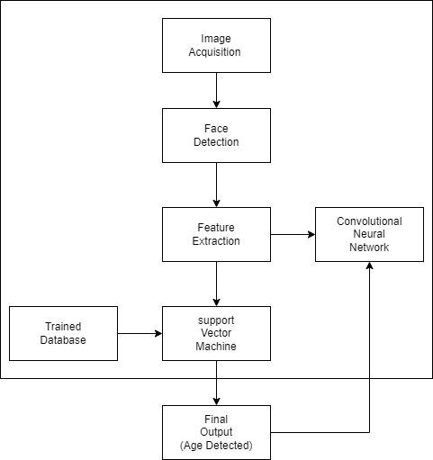

Figure 9. Diagram of the Data Flow

**3.10 System Architecture**

As illustrated in Figure 3.10, the initial step involves capturing user images through a webcam. The detected face is then processed using the available databases, which include separate datasets for different ages. Following the completion of this process and the passage through the Convolutional Neural Network (CNN) layers, the system is prepared to display the real-time age prediction output frame.

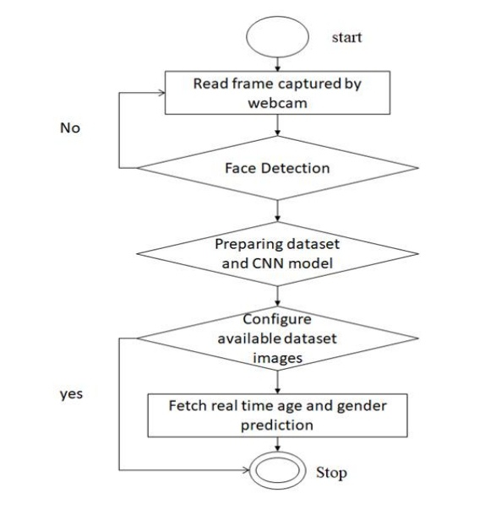

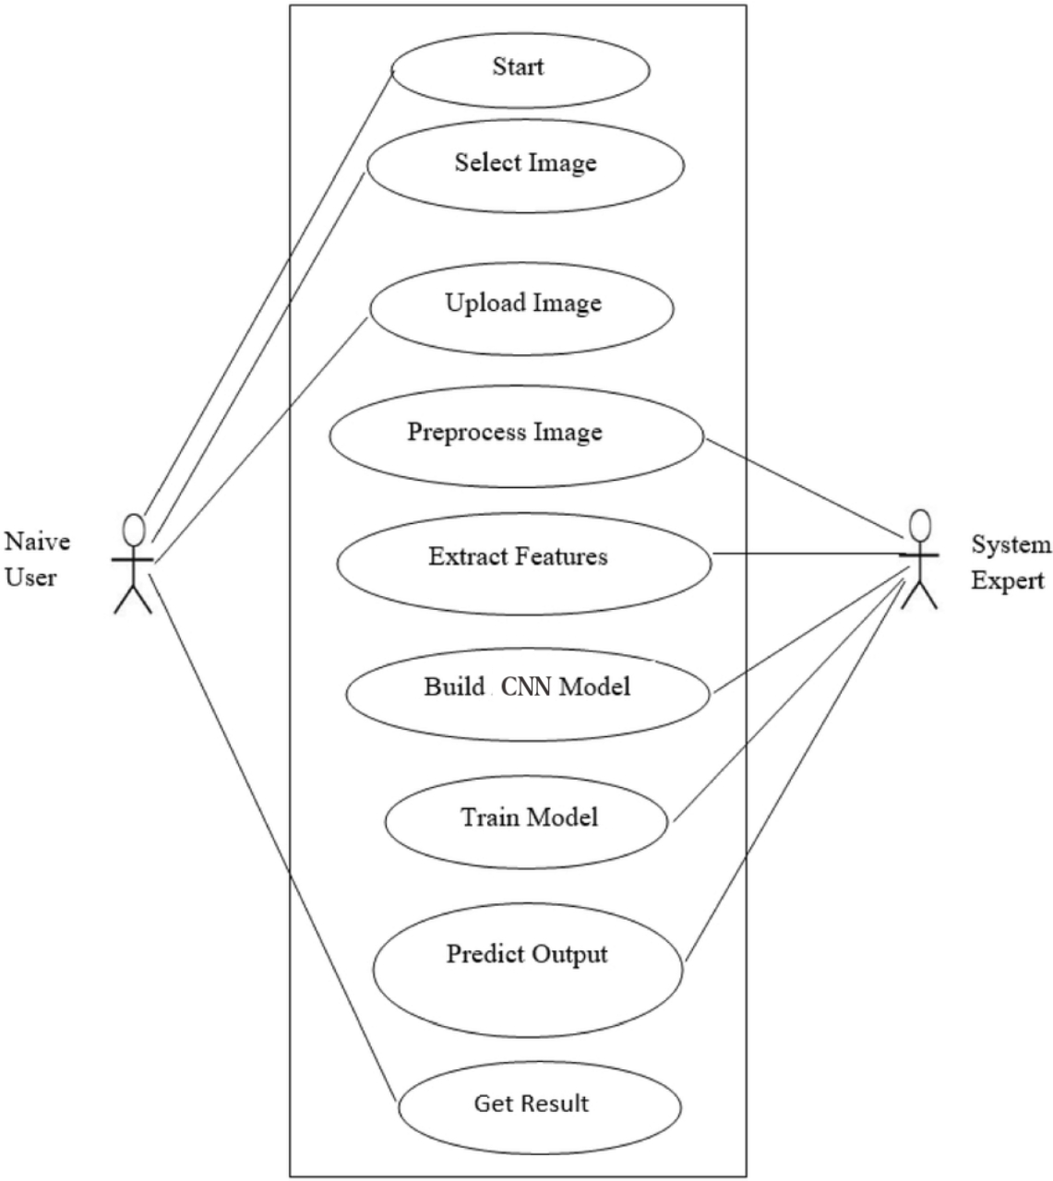

Figure 3.11 Use case Diagram

**CHAPTER FOUR**

**RESULT AND DISCUSSION**

**4.1 Overview**

This chapter discusses the results and implementation of an AI-based age detection system. The developed system facilitates accurate age estimation from photographs, providing a user-friendly interface for data input and analysis. The system distinguishes between different user roles, such as normal users and administrators, to streamline its functionality.

**4.2 System Implementation**

For the age detection system to function properly, it must be implemented in two major aspects: Software and Hardware.

**4.2.1 Software Requirements**

The software requirements for developing the age detection system are as follows:

* Python 3.9: The primary programming language for building and training the age detection model.
* TensorFlow 2.5: A machine learning framework used to develop and train deep learning models.
* Dlib: This is a popular toolkit for machine learning that is used primarily for computer vision and image processing tasks, such as face recognition, facial landmark detection, object detection, and more. It is written in C++ but has Python bindings, making it easily accessible from Python code
* Sightcorp: Sightcorp FACE is a facial recognition software solution developed by Sightcorp, a company specializing in AI-driven face analysis technology.
* OpenCV 4.5: A library for computer vision tasks, used for image preprocessing and feature extraction.

**4.2.2 Hardware Requirements**

The age detection system was developed and tested on a PC with the following specifications:

* Processor: Intel(R) Core(TM) i7-9750H CPU @ 2.60GHz 2.59 GHz
* RAM: 8GB
* Storage: 256GB SSD
* Core i5
* Operating System: 64-bit Windows 11

**4.3 Implementation Details**

The implementation of the AI-based age detection system involved a systematic approach to software development, integrating various technologies and frameworks to create a strong and user-friendly application. This chapter details the methodologies and processes undertaken to build the interface, connect the application to the camera, and ensure the system's functionality.

**4.3.1 Integration with camera functionality**

To access the camera functionality, OpenCV library is the most considerable library. OpenCV is a powerful library of Python for computer vision tasks, and it provides comprehensive functions to access and manipulate the camera.

Here's a basic example of how to use OpenCV to access your camera and capture frames, which you can then pass to your age detection model:

First, you need to install OpenCV. You can do this using pip:



Here’s a simple example of how to access the camera and capture frames using OpenCV:

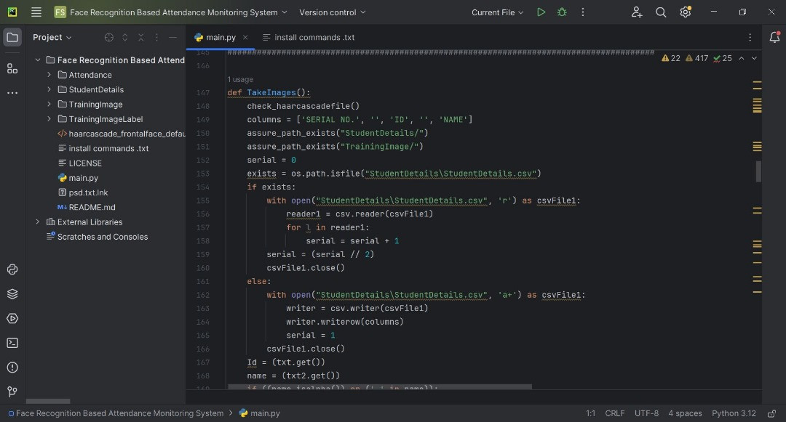

Figure 4.3.2. Simple python code for accessing camera using OpenCV

**4.3.3. Image Training**

Example code snippet to define and train a model using TensorFlow:

Figure 4.3.4 Tensor Flow code snippet for image training

**4.3.4. Model Evaluation**

After training, we use Tensor Flow to evaluate the model to understand its accuracy and other performance metrics.

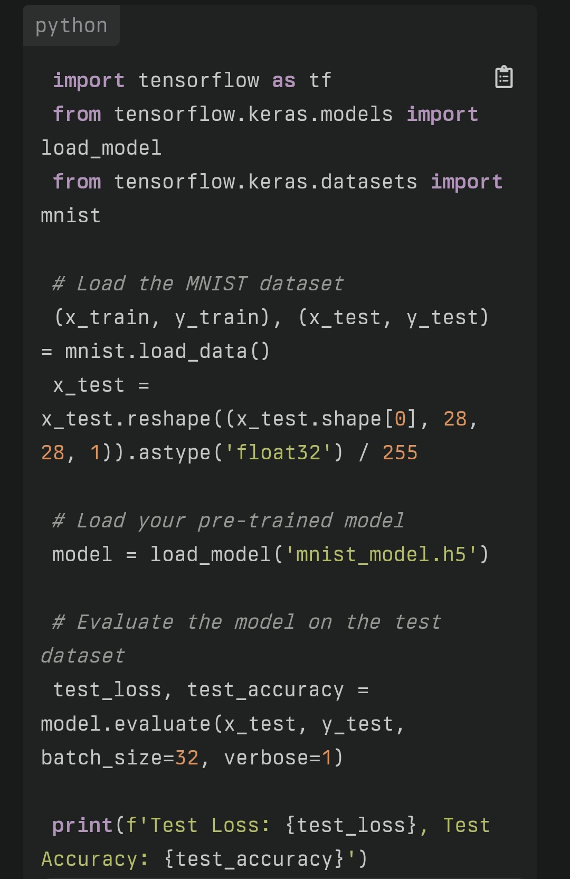

Figure 4.3.4. Code Snippet of model evaluation using Tensor Flow.

**4.3.5 Model Deployment**

Before deploying, ensure your model is saved in the Saved model format. This format is required for TensorFlow Serving.

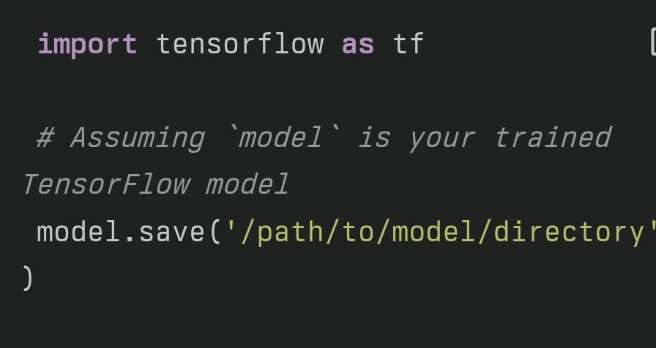

Figure 4.3.5. Code Snippet for Model deployment using Tensor Flow

**4.3.6. Integration with Application**

The API is created to serve the model and build a frontend to interact with the model.

First of all, Flask needs to be installed. Now, Flask is a simple web framework for Python that helps you build web applications quickly and easily.

After Flask is installed, a new Python file, app.py is created, and set up a basic Flask application to interact with the TensorFlow Serving API

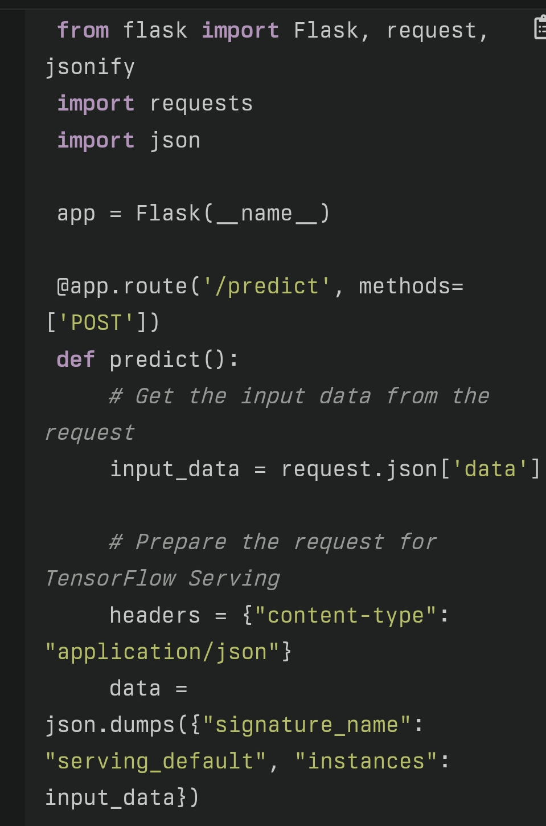

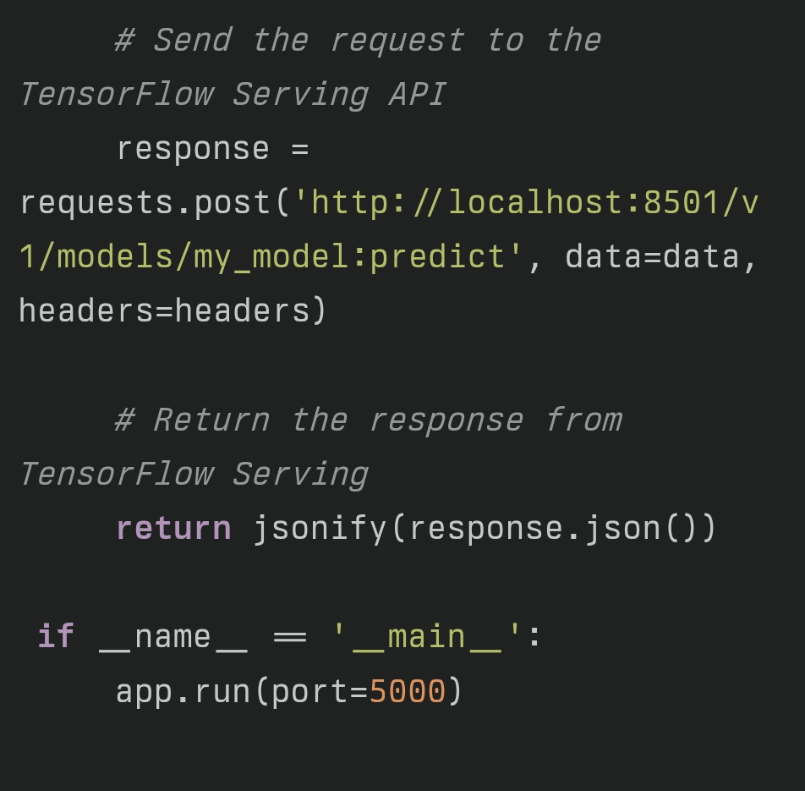

Figure 4.3.6. The Basic code snippet of serving API using Flask Framework

**4.4. User Roles**

In the age and gender detection application, normal users interact primarily by uploading images or using the webcam to capture real-time video feeds. The application's primary functionality involves detecting faces in these images or video frames, predicting the age and gender of the detected faces, and displaying the results in an intuitive and user-friendly interface. Users benefit from real-time feedback and accurate predictions provided by pre-trained models integrated into the application. The user interface is designed to be straightforward, allowing users to easily navigate, manage their uploads, and view prediction results without needing technical expertise. The application processes each frame to detect faces, applies age and gender prediction models, and highlights the detected faces with the predicted information. This setup ensures that users can interact seamlessly with the system, making it accessible and beneficial for everyday use.

**4.5 Library Used**

The project utilizes several key libraries to achieve its functionality. The primary library used is OpenCV (`cv2`), which is a powerful tool for real-time computer vision and image processing tasks. In this project, OpenCV is employed for multiple purposes. It captures video from the webcam or reads from an image file using the `cv2.VideoCapture()` function. This allows the application to process live video feeds or static images. The project leverages pre-trained neural network models for face detection, which are read and utilized through OpenCV’s DNN module. For instance, the models are loaded using `cv2.dnn.readNet(faceModel, faceProto)`, enabling the detection of faces in the provided images or video frames. Once faces are detected, OpenCV’s `cv2.rectangle()` function is used to draw rectangles around them, visually highlighting the detected areas.

The `math` library is also imported, although it is not directly used in the provided code snippet. Typically, the `math` library would be employed for various mathematical operations, such as calculations involving trigonometry, logarithms, or other advanced mathematical functions.

Lastly, the `argparse` library is utilized to handle command-line arguments. This allows users to specify an image file for processing when running the script. The `argparse.ArgumentParser()` is used to define the expected arguments, and `parser.parse_args()` retrieves these arguments. This functionality makes the application flexible, enabling it to work with both live video feeds and static image files based on user input.

Together, these libraries provide the necessary tools for capturing, processing, and analyzing images and video, allowing the application to perform real-time age and gender detection effectively.

**CHAPTER FIVE**

**SUMMARY, CONCLUSION ANS RECOMMENDATION**

**5.1 Summary**

This project aimed to create and implement an AI-based age detection system. The primary goal was to create and deploy a model capable of properly predicting an individual's age using visual inputs. Data gathering, model training, evaluation, deployment, and user interface design are all part of the system's architecture. We used cutting-edge machine learning techniques and technologies to create a reliable and scalable solution.

Throughout the implementation phase, special emphasis was placed on tackling the difficulty of age invariance, ensuring that the model operates consistently across a variety of settings and user demographics. The system underwent intensive testing, and feedback from early users was used to improve the interface and functionality.

**5.2 Conclusion**

The AI-based age detection system developed in this project has demonstrated a significant ability to accurately predict ages from images, with performance metrics meeting the desired standards. The system effectively addresses the problem of age invariance by leveraging a diverse dataset and employing advanced machine learning techniques. The integration of the model into a functional application has shown that the technology can be applied practically, offering a reliable tool for age estimation.

The project successfully met its objectives of developing an accessible and efficient age detection system. The user interface is designed for ease of use, while the backend technology assures reliable performance and safe data management. The ethical considerations and deployment challenges were addressed, resulting in a well-rounded and practical solution.

**5.3 Recommendations**

Based on the outcomes and observations from this project, several recommendations can be made to enhance the age detection system further. Future work should focus on expanding the dataset to include more diverse and representative samples, which will improve the model's ability to generalize across different populations. Incorporating additional biometric data or using advanced techniques, such as deep learning architectures, may also enhance accuracy and strength.

To increase deployment efficiency, consider optimizing computational resources and investigating alternate deployment settings that can provide better scalability and performance.

Finally, adding features like real-time processing or integration with other applications could widen the system's usability and influence in a variety of domains, including security, healthcare, and social media. By implementing these ideas, the age identification system can be modified and expanded, increasing its effectiveness and expanding its possible uses.

**REFERENCES**

Moreano, J. A. C., & Palomino, N. B. L. S. (2020). Global facial recognition using gabor wavelet, support vector machines and 3d face models. *Journal of Advances in Information Technology*, *11*(3).

Alreshidi, A., & Ullah, M. (2020, February). Facial emotion recognition using hybrid features. In Informatics (Vol. 7, No. 1, p. 6). MDPI.

Shiva, K.(2023 June) Generative Modeling with Variational Autoencoders

<https://www.linkedin.com/pulse/generative-modeling-variational-autoencoders-vaes-shiv-kumar?utm_source=share&utm_medium=member_android&utm_campaign=share_via>

M. Hu, P. Ge, X. Wang et al., "A spatio-temporal integrated model based on local and global features for video expression recognition", Vis Comput, vol. 38, pp. 2617-2634, 2022, [online] Available: https://doi.org/10.1007/s00371-021-02136-z.

CrossRef Google Scholar

V. Bazarevsky, Y. Kartynnik, A. Vakunov, K. Raveendran and M. Grundmann, "BlazeFace: Sub-millisecond Neural Face Detection on Mobile GPUs", Proceedings of Computer Vision & Pattern Recognition., 2019.

Google Scholar

Y G Kim and X P Huynh, "Discrimination Between Genuine Versus Fake Emotion Using Long-Short Term Memory with Parametric Bias and Facial Landmarks[C]", IEEE International Conference on Computer Vision Workshop., pp. 3065-3072, 2017.

View Article

Google Scholar

C Y Ma, M H Chen, Z Kira et al., "TS-LSTM and Temporal-Inception: Exploiting Spatiotemporal Dynamics for Activity Recognition[J]", 2017.

Google Scholar

Y. Karthynnik, A. Ablavatski, I. Grishchenko and M. Grundmann, "Real-time facial Surface geometry from monocular video on mobile GPUs", CVPR Workshop on Computer Vision for Augmented and Virtual Reality, 2019, [online] Available: https://doi.org/10.48550/arXiv.1907.06724.

Google Scholar

S. Singh and S. Benedict, "Indian semi-acted facial expression (iSAFE) dataset for human emotions recognition. Advances in Signal Processing and Intelligent Recognition Systems", Communications in Computer and Information Science, pp. 1209, 2019.

Google Scholar

P. Lucey, J. Cohn, T. Kanade, J. Saragih, Z. Ambadar and I. Matthews, "The extended Cohn–Kanade dataset (CK+): a complete dataset for action unit and emotion-specified expression", 2010 IEEE Computer Society Conference on Computer Vision and Pattern Recognition Workshops, pp. 94-101, 2010.

A. V. Savchenko, L. V. Savchenko and I. Makarov, "Classifying emotions and engagement in online learning based on a single facial expression recognition neural network", IEEE Transactions on Affective Computing, 2022.

Amit Dhomne, Ranjit Kumar, Vijay Bhan,” Gender Recognition Through Face Using Deep Learning”Procedia Computer Science,Volume 132, Pages 2-10, 2018.

Google Scholar

M. Kan, S. Shan, H. Chang and X. Chen, “Stacked Progressive Auto-Encoders (SPAE) for Face Recognition Across Poses,” 2014 IEEE Conference on Computer Vision and Pattern Recognition, Columbus, OH, 2014, pp. 1883-1890

Google Scholar

M. Fatahi, M. Ahmadi, A. Ahmadi, M. Shahsavari and P. Devienne, “Towards an spiking deep belief network for face recognition application,” 2016 6th International Conference on Computer and Knowledge Engineering (ICCKE), Mashhad, 2016, pp. 153-158.

Google Scholar

L.-C. Chen, G. Papandreou, I. Kokkinos, K. Murphy, and A. L. Yuille, “Semantic Image Segmentation with Deep Convolutional Nets and Fully Connected CRFs,” vol. 40, no. 4, pp. 834–848, 2014

Google Scholar

S. Ji, M. Yang, and K. Yu, “3D Convolutional Neural Networks for Human Action Recognition.,” Pami, vol. 35, no. 1, pp. 221–31, 2013 doi: 10.1109/TPAMI.2012.59

View

Web of Science ®Google Scholar

J. He, D. Li, B. Yang, S. Cao, B. Sun and L. Yu, “Multi View Facial Action Unit Detection Based on CNN and BLSTM-RNN,” 2017 12th IEEE International Conference on Automatic Face & Gesture Recognition (FG 2017), Washington, DC, 2017, pp. 848-853.

Google Scholar

E. Shelhamer, J. Long, and T. Darrell, “Fully Convolutional Networks for Semantic Segmentation,” IEEE Trans. Pattern Anal. Mach. Intell., vol. 39, no. 4, pp. 640–651, 2017. doi: 10.1109/TPAMI.2016.2572683

View

PubMed Web of Science ®Google Scholar

Xudong Sun, Pengcheng Wu, Steven C.H. Hoi, Face detection using deep learning: An improved faster RCNN approach,Neurocomputing,Volume 299,Pages 42-50,2018

Google Scholar

L. D. Introna and H. Nissenbaum, “Facial Recognition Technology. A Survey of Policy and Implementation Issues,” Cent. Catastr. Prep. Response, New York Univ., vol. 74, no. 5, pp. 1–60, 2009.

Google Scholar

Deepak Ghimire, Sunghwan Jeong, Joonwhoan Lee, Sang Hyun Park, Facial expression recognition based on local region specific features and support vector machines” Multimedia Tools and Applications, , pp 1-19, March 2016.

Google Scholar

D. Keysers, T. Deselaers, H. A. Rowley, L.-L. Wang, and V. Carbune, “Multi-Language Online Handwriting Recognition,” IEEE Trans. Pattern Anal. Mach. Intell., vol. 39, no. 6, pp. 1180–1194, 2017. doi: 10.1109/TPAMI.2016.2572693

View

PubMed Web of Science ®Google Scholar

Rein-Lien Hsu, M. Abdel-Mottaleb, and A. K. Jain, “Face detection in color images,” IEEE Trans. Pattern Anal. Mach. Intell., vol. 24, no. 5, pp. 696–706, 2002. doi: 10.1109/34.1000242

View

Web of Science ®Google Scholar

Wang, H.; Song, W.; Liu, W.; Song, N.; Wang, Y.; Pan, H. A Bayesian Scene-Prior-Based Deep Network Model for Face Verification. Sensors 2018, 18, 1906

Web of Science ®Google Scholar

X. Chen, C. Zhang, F. Dong and Z. Zhou, “Parallelization of elastic bunch graph matching (EBGM) algorithm for fast face recognition,” 2013 IEEE China Summit and International Conference on Signal and Information Processing, Beijing, 2013, pp. 201-205.

Google Scholar

C. Dong, C. C. Loy, K. He, and X. Tang, “Image Super-Resolution Using Deep Convolutional Networks,” IEEE Trans. Pattern Anal. Mach. Intell., vol. 38, no. 2, pp. 295–307, 2016. doi: 10.1109/TPAMI.2015.2439281

View

PubMed Web of Science ®Google Scholar

D. T. Nguyen, W. Li, and P. O. Ogunbona, “Human detection from images and videos: A survey,” Pattern Recognit., vol. 51, pp. 148–175, 2016. doi: 10.1016/j.patcog.2015.08.027

View

Web of Science ®Google Scholar

Shang-Hung Lin, Sun-Yuan Kung, and Long-Ji Lin, “Face recognition/detection by probabilistic decision-based neural network,” IEEE Trans. Neural Networks, vol. 8, no. 1, pp. 114–132, 1997. doi: 10.1109/72.554196

View

Web of Science ®Google Scholar

T. Heseltine, N. Pears, and J. Austin, “Evaluation of image pre-processing techniques for eigenface based face recognition,” Spie, vol. 4875, no. 2002, pp. 677–685, 2002.

Google Scholar

X. He, S. Yan, Y. Hu, P. Niyogi, and H. J. Zhang, “Face recognition using Laplacianfaces,” IEEE Trans. Pattern Anal. Mach. Intell., vol. 27, no. 3, pp. 328–340, 2005. doi: 10.1109/TPAMI.2005.55

View

PubMed Web of Science ®Google Scholar

Z. Lei, D. Yi and S. Z. Li, “Learning Stacked Image Descriptor for Face Recognition,” in IEEE Transactions on Circuits and Systems for Video Technology, vol. 26, no. 9, pp. 1685-1696, Sept. 2016. doi: 10.1109/TCSVT.2015.2473415

View

Web of Science ®Google Scholar

N. Liu, M. Lim, P. C. Yuen and J. Lai, “Image Set-Based Face Recognition: A Local Multi-keypoint Descriptor-Based Approach,” 2013 IEEE Conference on Computer Vision and Pattern Recognition Workshops, Portland , OR, 2013, pp. 160-165.

Google Scholar

Y. Sun, D. Liang, X. Wang, and X. Tang, “Deepid3: Face recognition with very deep neural networks,” arXiv Preprint, arXiv:1502.00873, 2015

Google Scholar

G. B. Huang, M. Mattar, T. Berg, and E. Learned-Miller, “Labeled faces in the wild: A database for studying face recognition in unconstrained environments,” vol. 1, no. 2, p. 3, Tech. Rep. 07-49, Univ. Massachusetts, Amherst, 2007.

Google Scholar

Z. Liu, P. Luo, X. Wang, and X. Tang, “Deep learning face attributes in the wild,” in Proc. IEEE Int. Conf. Computer Vision, 2015, pp. 3730–3738.

Google Scholar

L. Wolf, T. Hassner, and, I. Maoz, “Face recognition in unconstrained videos with matched background similarity,” in Proc. IEEE Conf. Computer Vision Pattern Recognition, 2011, pp. 529–534.

Google Scholar

S. Sengupta, J.-C. Chen, C. Castillo, V. M. Patel, R. Chellappa, and D. W. Jacobs, “Frontal to profile face verification in the wild,” in Proc. IEEE Winter Conf. Applications of Computer Vision, 2016, pp. 1–9.

Google Scholar

A. Bansal, A. Nanduri, C. Castillo, R. Ranjan, and R. Chellappa, “Umdfaces: An annotated face data set for training deep networks,” arXiv Preprint, arXiv:1611.01484, 2016.

Google Scholar

O. M. Parkhi, A. Vedaldi, and A. Zisserman, “Deep face recognition,” in Proc. British Machine Vision Conf., vol. 1, no. 3, 2015, p. 6.

Google Scholar

A. Nech and I. Kemelmacher-Shlizerman, “Level playing field for million scale face recognition,” in Proc. IEEE Int. Conf. Computer Vision Pattern Recognition, 2017, pp. 873–4882.

Google Scholar

J. R. Beveridge, P. J. Phillips, D. S. Bolme, B. A. Draper, G. H. Givens, Y. M. Lui, M. N. Teli, H. Zhang, W. T. Scruggs, K. W. Bowyer, and P. J. Flynn, “The challenge of face recognition from digital point - and - shoot cameras,” in Proc. IEEE Int. Conf. Biometrics: Theory, Applications and Systems, 2013, pp. 1–8.

Google Scholar

B. F. Klare, B. Klein, E. Taborsky, A. Blanton, J. Cheney, K. Allen, P. Grother, A. Mah, M. Burge, and A. K. Jain, “Pushing the frontiers of unconstrained face detection and recognition: IARPA Janus Benchmark A,” in Proc. IEEE Conf. Computer Vision Pattern Recognition, 2015, pp. 1931–1939.

Google Scholar

A. Bansal, C. D. Castillo, R. Ranjan, and R. Chellappa, “The do’s and don’ts for CNN-based face verification,” arXiv Preprint, arX-iv:1705.07426, 2017.

Google Scholar

S. Nagendra, R. Baskaran, and S. Abirami, “Video-Based Face Recognition and Face-Tracking using Sparse Representation Based Categorization,” Procedia Comput. Sci., vol. 54, pp. 746–755, 2015. doi: 10.1016/j.procs.2015.06.088

view

View

Google Scholar

S. Arya, N. Pratap, and K. Bhatia, “Future of Face Recognition: A Review,” Procedia Comput. Sci., vol. 58, pp. 578–585, 2015. doi: 10.1016/j.procs.2015.08.076

view

View

Google Scholar

T. Heseltine, N. Pears, and J. Austin, “Three-dimensional face recognition: An eigensurface approach,” Image Process. 2004. ICIP’, vol. 2, pp. 1421–1424, 2004.

Google Scholar

Francesco Ziliani, Andrea Cavallaro, Image Analysis for Video Surveillance Based on Spatial Regularization of a Statistical Model-Based Change Detection, Real-Time Imaging, Volume 7, Issue 5, 2001, Pages 389-399, doi: 10.1006/rtim.2000.0208

View

Google Scholar

Tat-Jun Chin, U. James, K. Schindler and D. Suter, “Face Recognition from Video by Matching Image Sets,” Digital Image Computing: Techniques and Applications (DICTA’05), Queensland, Australia, 2005, pp. 28-28.

Google Scholar

T. Heseltine, N. Pears, J. Austin, and Z. Chen, “Face recognition: A comparison of appearance-based approaches,” Proc. VIIth Digit. image Comput. Tech. Appl., vol. 1, no. Section 9, pp. 10–12, 2003.

Google Scholar

Shruthi Nagendra; R. Baskaran; S. Abirami “Video-Based Face Recognition and Face-Tracking using Sparse Representation Based Categorization” Procedia Computer Science, ISSN: 1877-0509, Vol: 54, Page: 746-755,2015.

Google Scholar

S. Nagendra, R. Baskaran, and S. Abirami, “Video-Based Face Recognition and Face-Tracking using Sparse Representation Based Categorization,” Procedia Comput. Sci., vol. 54, pp. 746–755, 2015. doi: 10.1016/j.procs.2015.06.088

view

View

Google Scholar

E. G. Ortiz, A. Wright and M. Shah, “Face Recognition in Movie Trailers via Mean Sequence Sparse Representation-Based Classification,” 2013 IEEE Conference on Computer Vision and Pattern Recognition, Portland, OR, 2013, pp. 3531-3538.

Google Scholar

H. Boukamcha, M. Elhallek, M. Atri and F. Smach, “3D face landmark auto detection,” 2015 World Symposium on Computer Networks and Information Security (WSCNIS), Hammamet, 2015, pp. 1-6.

Google Scholar

P. Nair, A. Cavallaro, “3-D Face Detection Landmark Localization and Registration Using a Point Distribution Model”, IEEE Trans. Multimedia, vol. 11, no. 4, pp. 611-623, June 2009. doi: 10.1109/TMM.2009.2017629

View

Web of Science ®Google Scholar

YILihamu YAErmaimaiti (2018) A new Uyghur face recognition algorithm, Journal of Interdisciplinary Mathematics, 21:5, 1055-1060, DOI: 10.1080/09720502.2018.1493029

View

Web of Science ®Google Scholar

Liping Lv (2018) An improved neural network algorithm for acceleration sensor to recognize human posture, Journal of Discrete Mathematical Sciences and Cryptography, 21:3, 789-795, DOI: 10.1080/09720529.2018.1449318

View Web of Science ®Google Scholar

Harandi, Mehrtash & Nili Ahmadabadi, Majid & Araabi, Babak. (2007). A hybrid model for face recognition using facial components. 1 - 4. 10.1109/ISSPA.2007.4555282.